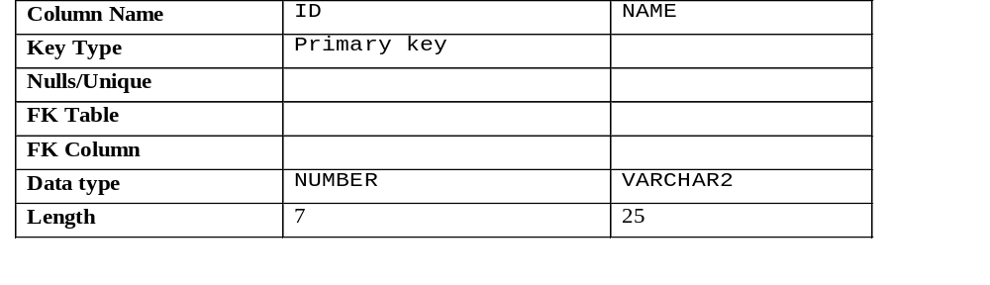1. Create the DEPT table based on the following table instance chart. Place the
syntax in a script called lab_09_01.sql, then execute the statement in the script to create the table. Confirm that the table is created.

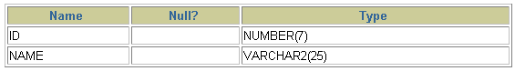
2. Populate the DEPT table with data from the DEPARTMENTS table. Include only columns that you need.
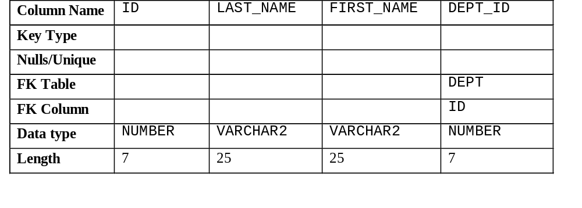3. Create the EMP table based on the following table instance chart. Place the syntax in
a script called lab_09_03.sql, and then execute the statement in the script to create the table. Confirm that the table is created.

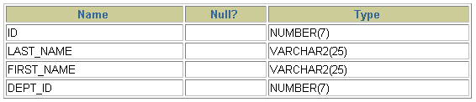
4. Create the EMPLOYEES2 table based on the structure of the EMPLOYEES table. Include only the EMPLOYEE_ID, FIRST_NAME, LAST_NAME, SALARY, and DEPARTMENT_ID columns. Name the columns in your new table ID, FIRST_NAME, LAST_NAME, SALARY , and DEPT_ID, respectively.
5. Drop the EMP table.

